The process of image classification through deep convolutional neural networks usually requires both vast labeled datasets and high-performance computing resources. Transfer learning is one of the methods that can solve this issue by using the pretrained models that have been trained on large-scale datasets. In this research, the ResNet-18 model that was pretrained on ImageNet is used for the selected subset of the Caltech-256 dataset which contains ten object categories. The pretrained model is modified by replacing the classification layer with a new one that is trained while the previous layers are frozen. Other experiments comprise hyperparameter tuning, early stopping, and partial fine-tuning of deeper layers. Results of the experiments reveal very good generalization performance with a test accuracy of 92.55%, which is a clear proof of the transfer learning being very effective for multi-class image classification even when the data is limited.
Image Classification on a Subset of the Caltech-256 Dataset Using Transfer Learning with ResNet-18
Hnin Lwin

Keywords:
Transfer Learning, Image Classification, ResNet-18, Caltech-256, Deep Learning, PyTorch

INTRODUCTION
Image classification challenges computer vision but it opens avenues in object recognition, surveillance, and content-based image retrieval. Classical methods made use of features that were manually crafted and these often could not cope with the complex variations in the visual domain. The advent of deep learning through convolutional neural networks (CNNs) has brought about an enormous performance boost by automatically extracting hierarchical representations of the features directly from the data.

The training of deep neural networks from scratch is a very resource and time-consuming task as it requires large, annotated datasets and huge computational power. The method of Transfer learning helps to alleviate these difficulties by allowing the use of the knowledge obtained from models that were previously trained on big datasets, like ImageNet. Residual Networks (ResNet) have made it possible to reach extremely large depths by means of skip connections and they have become the standard backbone for various vision tasks.

In this project, we will evaluate the performance of ResNet-18 model pre-trained on ImageNet in the multi-class image classification task on a small variant of the Caltech-256 dataset. The aims are to
(1) measure transfer learning performance as a baseline,
(2) study training convergence
(3) the effects of hyperparameter tuning and fine-tuning approaches.

Dataset Description
The Caltech-256 dataset contains 30,607 images distributed across 257 object categories. For computational efficiency and controlled experimentation, a subset of 10 classes was selected, including ak47, American-flag, backpack, baseball-bat, baseball-glove, basketball-hoop, bat, bathtub, bear, and beer-mug.

A total of 1,245 images were used. The dataset was split into:
- 70% training
- 15% validation
- 15% testing

Random splitting was performed with a fixed seed to ensure reproducibility. The class distribution remained moderately balanced across splits.

Data Preprocessing and Augmentation
All images resized to 224 × 224 pixels, which was the input requirement of ResNet-18. Data augmentation was applied in training set which helped in improving generalization and reducing overfitting. These methods were:

- Random resized cropping
- Horizontal flipping
- Random rotation (±15°)

Images were normalized to the mean and standard deviation of ImageNet, this way, pretrained weights could be used. Validation and test datasets used deterministic center cropping without augmentation.

Model Architecture and Training Setup

Network Architecture
The backbone model that was used is ResNet-18 which had been pretrained on ImageNet. At first, all convolutional layers were frozen while a new linear layer that corresponds to 10 output classes was substituted for the last fully connected layer.

Training Configuration
The model was trained using:
- Loss function: Cross-Entropy Loss
- Optimizer: Adam
- Initial learning rate: 0.001
- Batch size: 32
- Epochs: 10 (baseline), extended to 15 with early stopping
Training was performed using PyTorch in a GPU-enabled environment when available.

Hyperparameter Tuning and Fine-Tuning
Hyperparameter tuning mainly centered on learning rate and batch size. The top configuration got a validation accuracy of 91.94% with a learning rate of 0.001 and batch size of 32. To avoid overfitting, early stopping was applied based on validation loss, and in addition, partial fine-tuning was attempted by unfreezing the last residual block (layer4) while the previous layers were still frozen. This approach allowed for better feature adaptability and more stable training at the same time.

Experimental Results

Convergence Analysis
The training and validation loss curves show a gradual convergence, with the validation loss going down continuously and leveling off after about 10-12 epoch. The accuracy curves reflect a quick rise in the early epoch, then leveling off, which is a sign of the efficient use of features derived from the pretrained weights. The figure below shows the convergence loss and the Accuracy plot
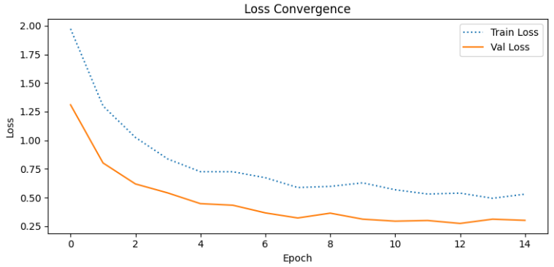
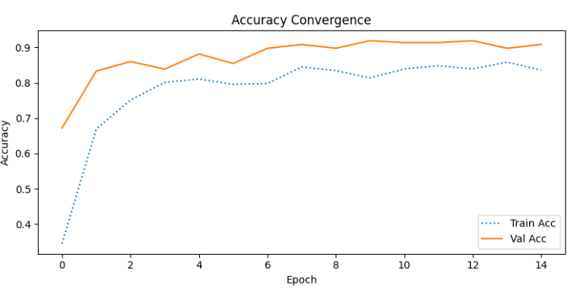

Training Configuration
The final model achieved a test accuracy of 92.55%. The table below summarizes per-class performance.
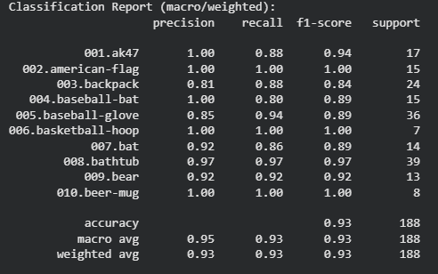
The confusion matrix indicates minimal inter-class confusion, with most errors occurring between visually similar object categories.

Discussion
The findings validate that the application of transfer learning with ResNet-18 proves to be very efficient for multi-class image classification on restricted datasets. Freezing of pretrained layers not only noticeably shortened the training duration but also helped to keep performance strong. Hyperparameter tuning along with early stopping made the model more stable and less prone to errors. Although partial fine-tuning gave slight improvements, it also made computation more expensive, thus revealing a trade-off between accuracy and efficiency.

Conclusion and Future Work
The results of this study show that the use of pretrained CNNs can work wonders even with very limited datasets and only a little training. The method proposed got over 92% test accuracy on a ten-class subset of Caltech-256. Among the future works, one can mention, for example, the investigation of deeper architecture, full fine-tuning, mitigation of class imbalance, and evaluation on larger subsets of the dataset.
Acknowledgment
I would like to thank the course instructor for guidance and the PyTorch and Caltech-256 communities for providing open-source tools and datasets that enabled this work.
References
[1] K. He, X. Zhang, S. Ren, and J. Sun, “Deep residual learning for image recognition,” Proc. IEEE Conf. Comput. Vis. Pattern Recognit., 2016.
[2] J. Deng et al., “ImageNet: A large-scale hierarchical image database,” CVPR, 2009.
[3] G. Griffin, A. Holub, and P. Perona, “Caltech-256 object category dataset,” Caltech Technical Report, 2007.
[4] PyTorch, “ResNet-18 Pretrained Models,” https://pytorch.org

 

